Order Form

From:
SodaAntarctica&Co |  | 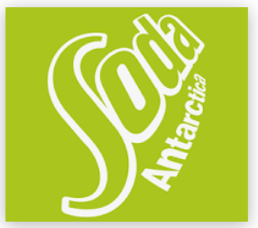
Customer No.: 44452

Ship To: Redline Auto Center

16040 S. US 27
Lansing, Michigan 48906
517-367-7010 johnsmith@redline.com

Order No: 9913781 | Delivery Via : Air & Land | Routing : N/A
Art nr | Art Name |  | Description | Unit Count | Unit Price | Total | ETA
A10121 | Fanta | Product description |  | EA: 48 | 1,2 | 57,6 | 05-08-2026
A10102 | Cola-light | Product description |  | EA: 24 | 1,1 | 26,4 | 05-08-2026
A10140 | Cola | Product description |  | EA: 72 | 0,9 | 64,8 | 05-08-2026
A10135 | Soda XX | Product description |  | EA: 24 | 1,2 | 28,8 | 05-08-2026
A10123 | Spark. W | Product description |  | EA: 24 | 1,2 | 28,8 | 05-08-2026
A10127 | Cola-light | Product description |  | EA: 24 | 1,2 | 28,8 | 05-08-2026
A10113 | Pepsi | Product description |  | EA: 48 | 1,1 | 52,8 | 05-08-2026
A10167 | Fanta-Light | Product description |  | EA: 48 | 0,9 | 43,2 | 05-08-2026
A10192 | Lemonbrew | Product description |  | EA: 48 | 1,2 | 57,6 | 05-08-2026
A10152 | Iced tea | Product description |  | EA: 24 | 1,2 | 28,8 | 05-08-2026
A10132 | Sprite | Product description |  | EA: 24 | 0,9 | 21,6 | 05-08-2026
A10122 | Soda-Mix | Product description |  | EA: 12 | 1,2 | 14,4 | 05-08-2026
A10162 | Cuba-C | Product description |  | EA: 24 | 1,2 | 28,8 | 05-08-2026

Note/Comments:  We are thirsty hurry up | Date: 15-07-2026 |   Approver’s signature:
 | Purchaser

